Name - ___________________________
Date - ____________ Section _______
Lab Partner - ______________________

Your Grade

__________________

HR Diagram – Worksheet

Part 1: Plotting the Stars
Below is a zoomed in image of the Jewelbox Star Cluster that was seen in the background information. This star cluster is located at a distance of 6,440 light years (37,858,000,000,000,000 miles) from Earth. You will notice various colors as well as sizes of these stars. The color of the star relates directly to its temperature, and is typically labeled by a letter. The size, since they are all at the same distance, relates directly to how bright the star is. In this exercise, you will plot the color and brightness of a sample of stars from the Jewelbox Cluster. The red circle outlines a random sample of the stars in the cluster. You only have to do the activity for the stars lying inside the red circle.
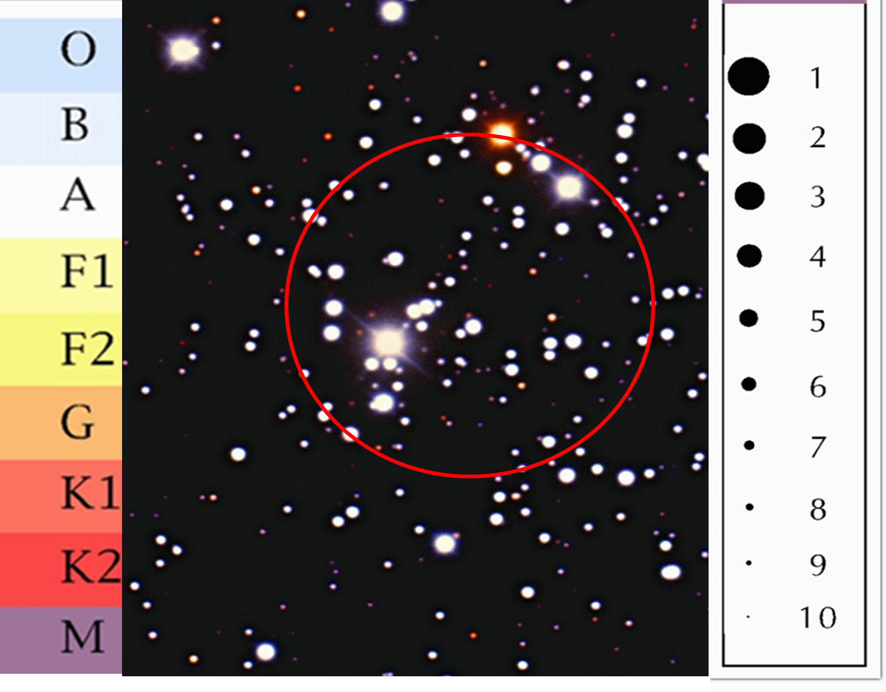

Problem 1) Measure the brightness of a given star within the cluster from its size in the image in comparison to the dots on the legend on the right. Then, measure the color using the color legend on the left. Place a dot on the graph provided below in the box that corresponds to the brightness and color you have determined for the star. (You can print the graph or use Microsoft Word to insert a circle from the InsertShapes option)

Proceed in some methodical way to determine and plot the brightness and color of every star within the red circle.

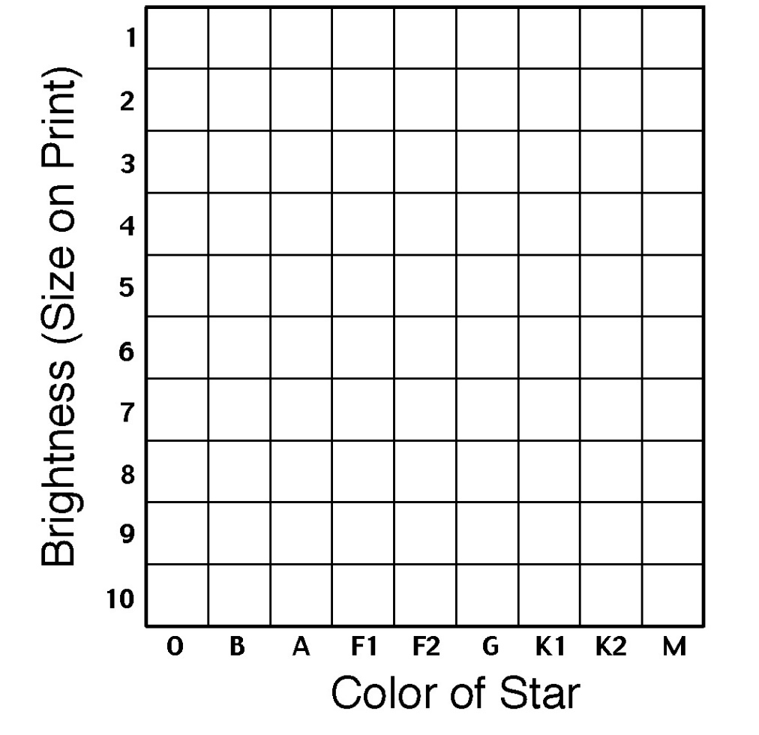

30 Points

Part 2: Questions
Problem 2) Do the stars on your graph appear to be randomly scattered or do they fall in any kind of pattern?
3 Points

Problem 3) Looking at your chart, do you notice more O/B (blue) or more K/M (red) stars?
3 Points

Problem 4) Thinking about our star, the Sun, what letter do you think it would be classified as? Why?
4 Points

Part 3: Determining the age of the cluster
The band in your graph from the upper-left corner to the lower-right corner is called the “main sequence”. It consists of young stars. When stars become old, the internal forces in a star get out of balance, eventually leading to the slow death of the star. These unbalanced forces cause a change the size (brightness) and temperature (color) of the star. Most stars become cooler (more red) and bigger (brighter) as they enter their dying (red-giant) phase. This moves them off-of the main sequence, towards the upper right corner of the graph. Astronomers can determine a cluster's age by looking the brightness of stars still on the main sequence band.

Below is a schematic version of the HR – diagram indicating the main sequence and giant and dwarf stars.

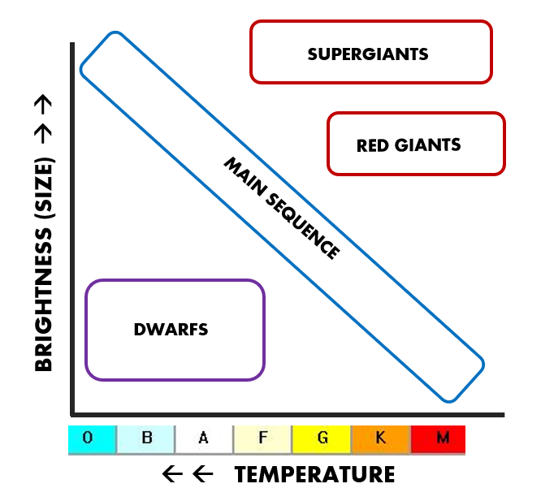

Problem 5) Using the sample graphs and ages below as a key, estimate the age range of the Jewelbox Cluster from your graph.

5 Points

Problem 6) Using the 3 graphs above, what can you say about the lifetimes of O/B stars compared to the lifetimes of K/M stars?
5 Points

